LOCATION : GENEL
DATE : 26.05.2017
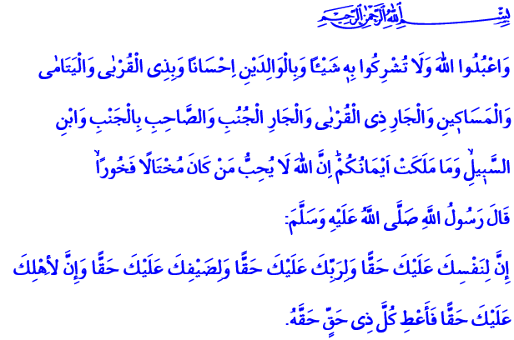
EVERY SOUL HAS A RIGHT UPON US
A Blessed Friday to You, Brothers and Sisters
In the verse I have recited, the Almighty enjoins: “Worship Allah. Associate nothing with Him. To parents do good, and to relatives, orphans, the needy, the near neighbor, the neighbor farther away, the companion at your side, the traveler, and those for whom you are responsible. Indeed, Allah does not like those who are self-deluding and boastful.”
In the hadith I have recited, our Prophet (pbuh) says: “Indeed your self has a right upon you, your Lord has a right upon you, your guest has a right upon you, and your family has a right upon you. So give each the right they are due!”
Honorable Believers!
Many thanks to the Almighty that he has brought us to another Ramadan, the month of grace, prosperity, and mercy. We will experience the joy of the first tarawih altogether this evening. We will have the peace of the first sahur altogether tonight. We will experience the enthusiasm of our first fasting tomorrow. We will try to host as well as we can the school of Ramadan which will stay at our house for a month.
Brothers and Sisters!
Students of the Ramadan school are all believers. This schools teaches us dedication, patience, gratitude, and appreciating the blessings. It reminds us of our responsibilities towards Allah, towards one another, and towards people we know. It points out to us that every soul has a right upon us. The greatest lesson we can take from this school is to make our fasting, sahur, iftar, tarawih, and all good deeds instruments in abiding by the right of one another. To renew our promise to look out for the right of our spouses and children, our parents, our neighbors and relatives, our employees or employers. To solidify our commitment to not ignore the situation of the orphans, the homeless, and every soul in need.
Brothers and Sisters!
Our parents have a right upon us. Because they brought us into the world through so many hardships. They raised and prepared us for life by fighting against many difficulties. Then come! Let us be good daughters and sons to our parents at all times this Ramadan. Let us not spare our respect and mercy from them.
Our spouses and children have a right upon us. Because they have been entrusted to us by Allah. They are our values with whom we undertake the burden of life. Then come! Let us treat our spouses and children with love, compassion, affection, and fondness. Let us raise our children as generations that contribute to Islam and to humankind who know their Lord, their religion, their prophet, and their book well.
Brothers and Sisters!
Our relatives and neighbors have a right upon us. Because they are an opportunity for prosperity for us. Then come! Let us keep in touch with them. Let us share their joy and sorrow. Let us not abandon them into loneliness among the crowd.
The orphans have a right upon us. Because they are a test for us. Then come! Let us look after the orphans. Let us hold their hands and prepare them for life. Let us not forget that the tiniest spark we will cause in their eyes will be the biggest happiness for them and the most lasting gain for us.
Dear Brothers and Sisters!
Every person, every being has a right upon us. Because this world belongs to others as well as us. Then come! Let us take heed of rights. Remember that we can protect our own rights to the extent that we protect the right of others. We can expect our right to be respected to the extent that we respect the right of others.
Brothers and Sisters!
Our presidency will point out to the concept of right this Ramadan with the theme “Every Being Has a Right upon You, This Ramadan and Always.” It will make an effort to reinforce the awareness of rights which gets weaker every day. With these thoughts and sentiments, I pray to Allah that holy Ramadan may bring good things to our nation, to the world of Islam, and to humankind. May He grant us to be among those who respect rights and whose rights are respected.

An-Nisa, 4/36.
Tirmidhi, Zühd, 63.
Abu Dawud, Tatavvû, 27. Written by: General Directorate of Religious Services

